HYCU Disaster Recovery Scenario for Google Cloud
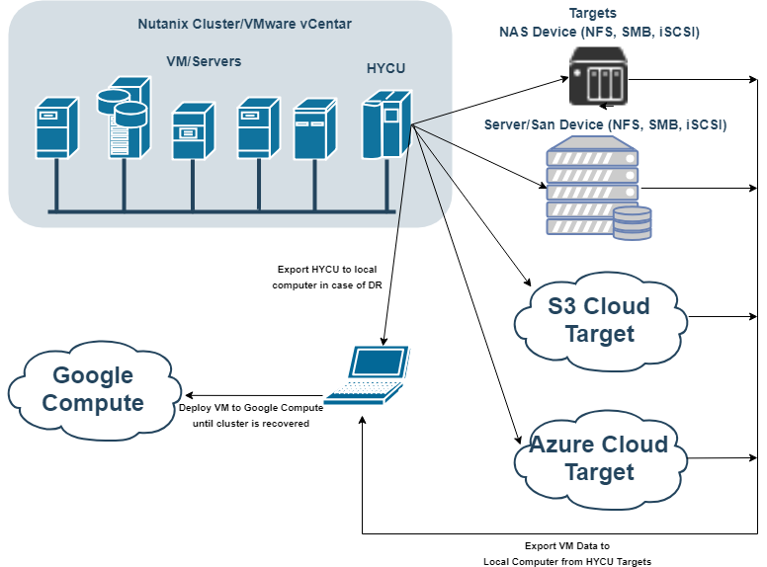

Prerequisites:
- Working Windows Physical Machine
- VMware Workstation player available for download on https://www.vmware.com/products/workstation-player/workstation-player-evaluation.html
- Installed and configured QEMU package for converting disk image files, Download QEMU From https://www.qemu.org/
- Backup of the HYCU backup controller (exported disk image files)
NOTE: use CTRL+ left mouse click on video links to open video
IMPORTANT: Watch for uppercase and lowercase letters in command

Contents
PREREQUISITE STEP 1 - Install QEMU tool 4
PREREQUISITE STEP 2 - Retrieve HYCU VM disk image files from backup target 6
STEP 1 – Recreate HYCU VM from its backup, using VMware Player 9
STEP 2 - Use HYCU to recover production virtual machines disk image files 16
STEP 3 – Download and install Google Cloud SDK 18
STEP 4 – Create Bucket and upload VM files 19
STEP 5 – Import VM disk to custom images 20
STEP 6 – Deploy VM from custom image 21

PREREQUISITE STEP 1 - Install QEMU tool
  - video file
- Get QEMU from https://www.qemu.org/
- Install QEMU to local computer
- Add QEMU Install folder to Path Environment Variable
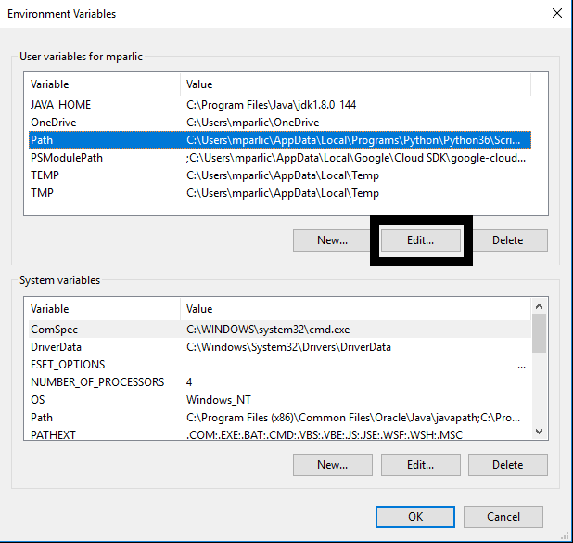
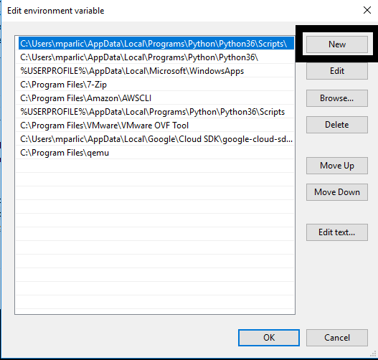
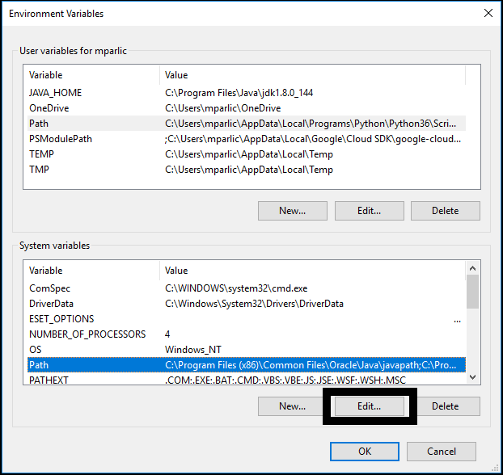
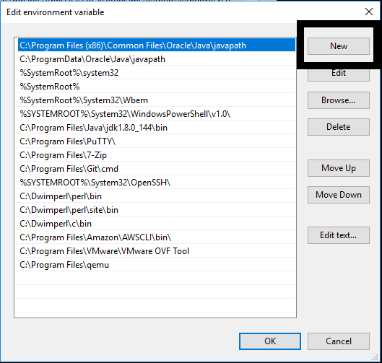

PREREQUISITE STEP 2 - Retrieve HYCU VM disk image files from backup target
  - video file
- Navigate to the target where backup of your HYCU backup controller is kept
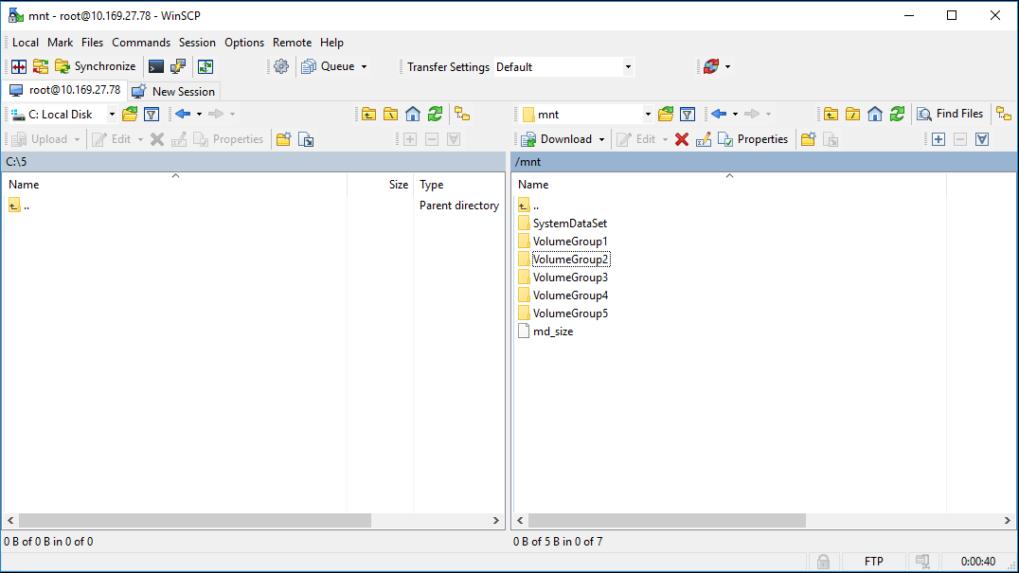
- Navigate to bkpctrl directory
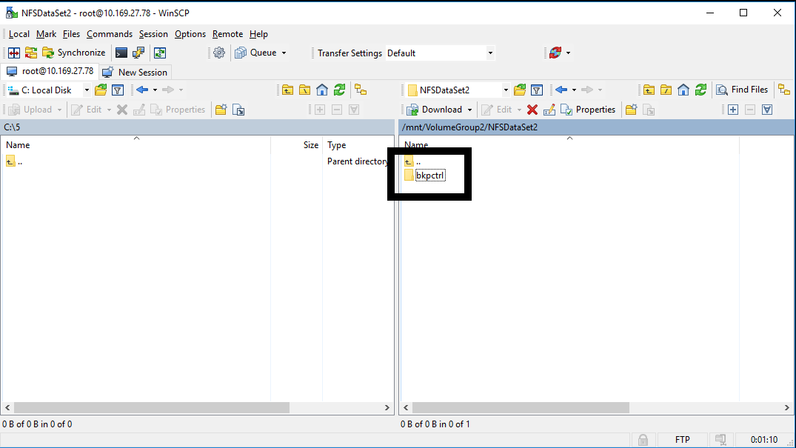
- Navigate to the HYCU uuid directory
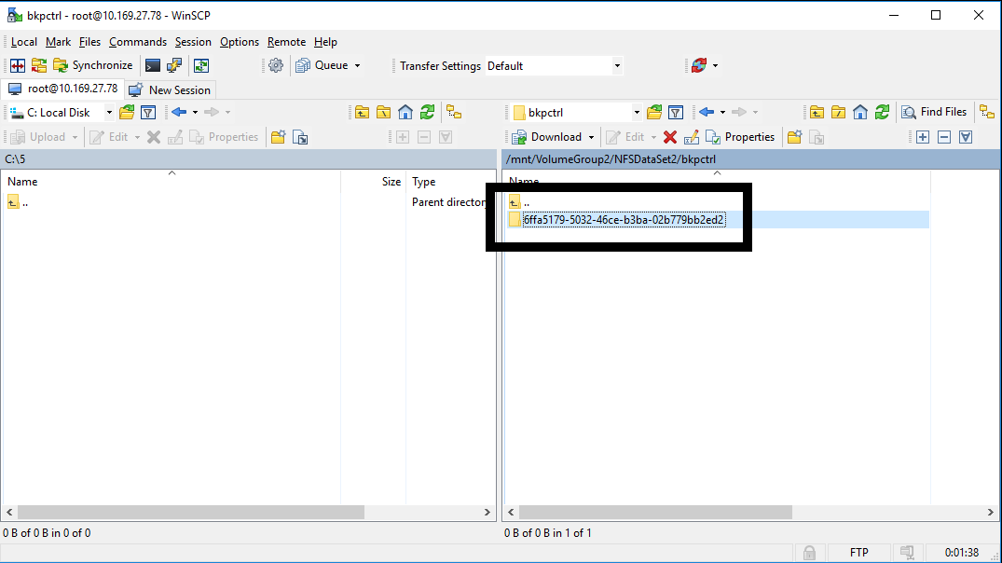

- Navigate to the directory internal_backup_<source UUID>
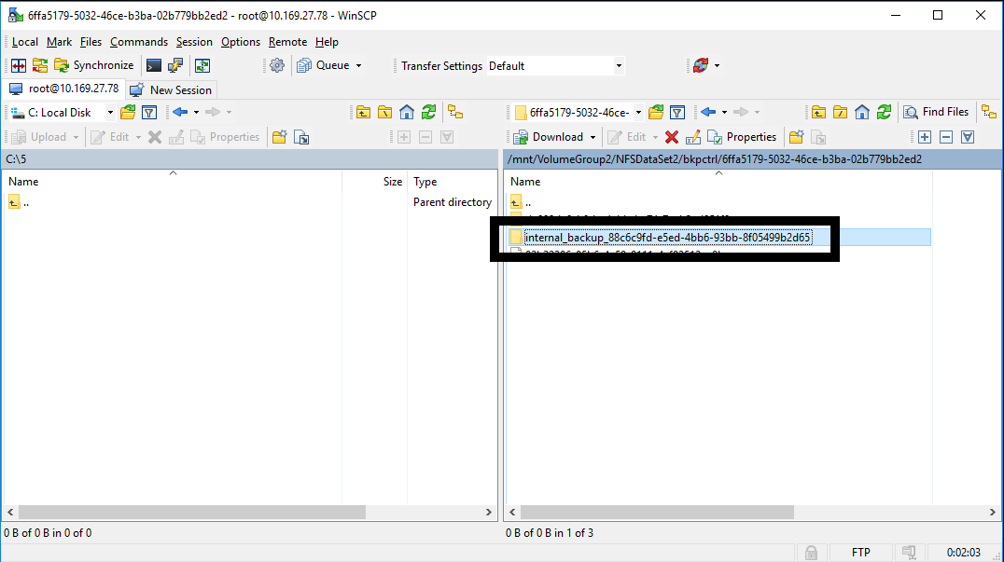
- Copy only the AHV raw disk image files (no extension) of HYCU backup controller disks to your local computer
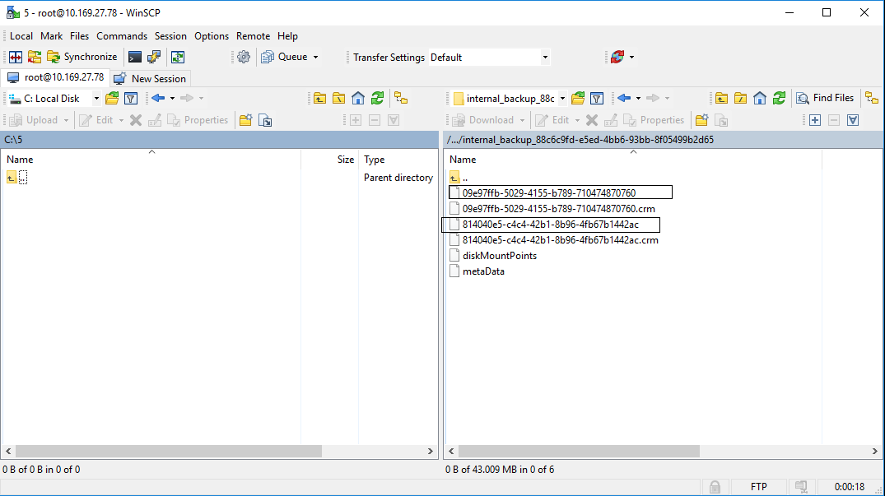
- Convert raw AHV disk image files to VMDK using QEMU tool
  - Smaller file (by default 10GB) is the HYCU system boot disk, the other one is HYCU data disk
  - Use the following commands
qemu-img convert -f raw -O vmdk <system disk image file> boot.vmdk
qemu-img convert -f raw -O vmdk <data disk image file> data.vmdk

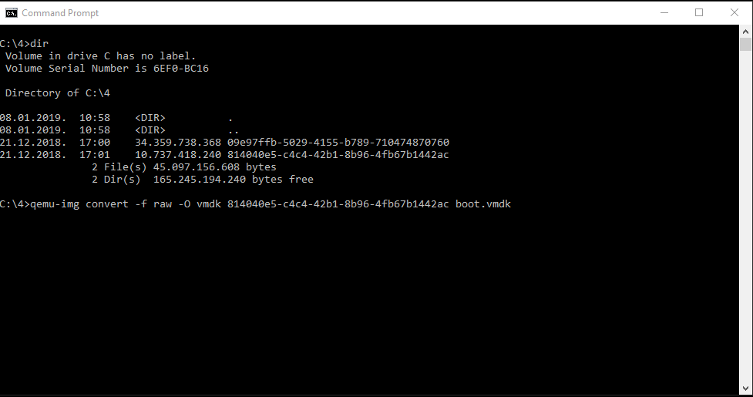
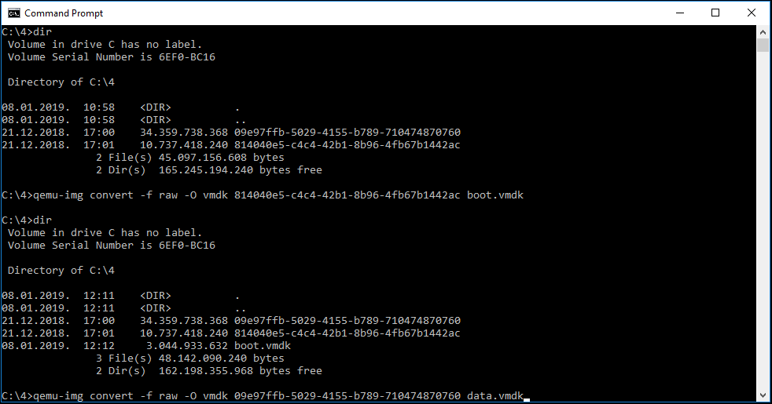

STEP 1 – Recreate HYCU VM from its backup, using VMware Player
  - video file
- Select Create New Virtual Machine
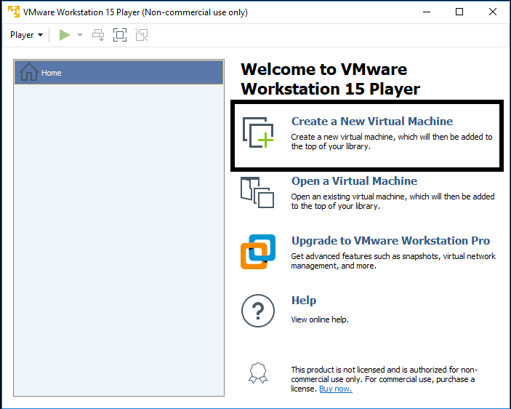
- On the next screen select “I will install operating system later”
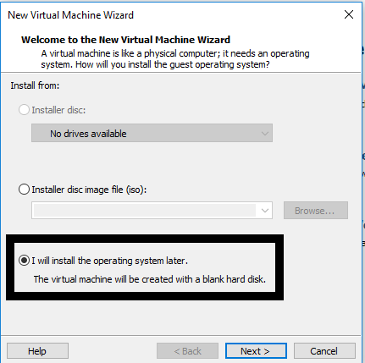
- On the next screen select Linux on top and Version CentOS 7 64-bit
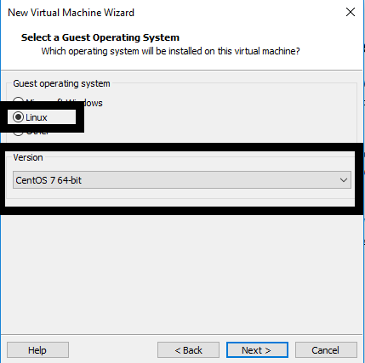

- Enter the VM name and select location on local computer where VM will be stored
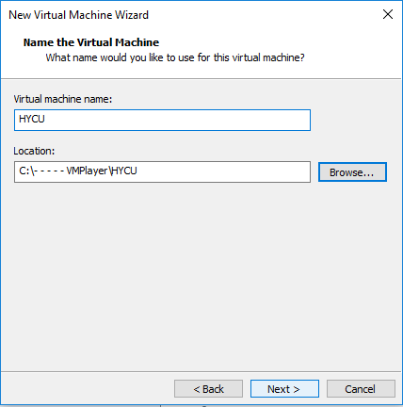
- Enter the size of VM boot disk (by default this is 10 GB) and select “Store Virtual disk as a single file”
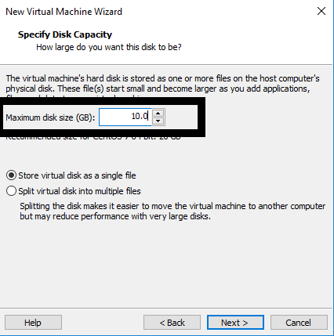
- Review VM details and click on Finish
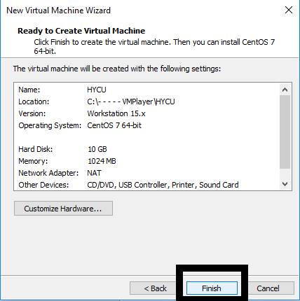

- Copy HYCU boot and data converted vmdk disk image files to the folder where your new VM was created
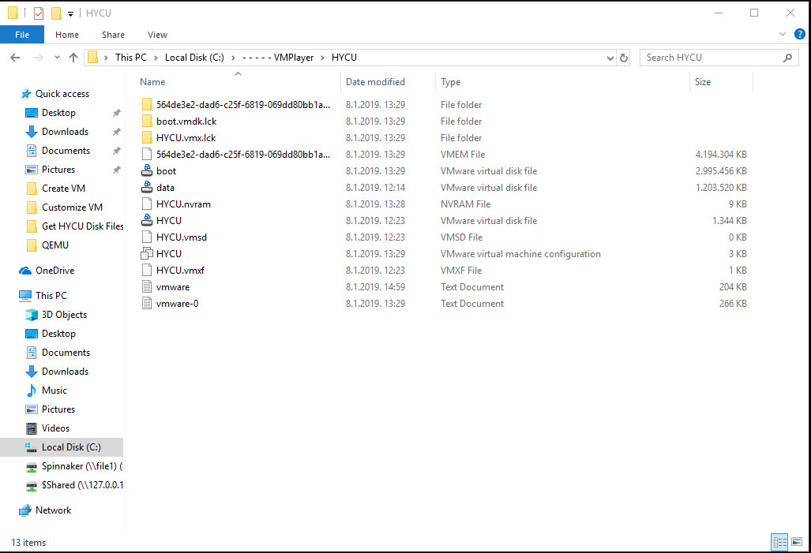
- Edit the .vmx file with a text editor. .vmx file is located in the folder where you created the new VM (change line scsi0:0.fileName = "HYCU.vmdk" to scsi0:0.fileName = "boot.vmdk")
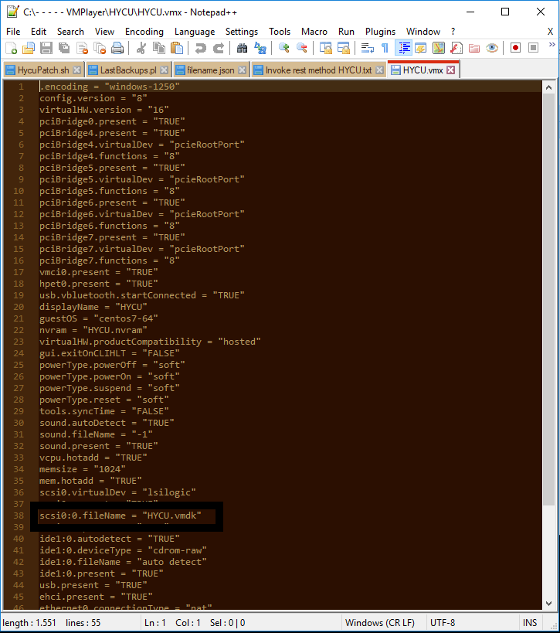
- Save the File

- Open VM player, select the VM and Select "Edit virtual machine settings"
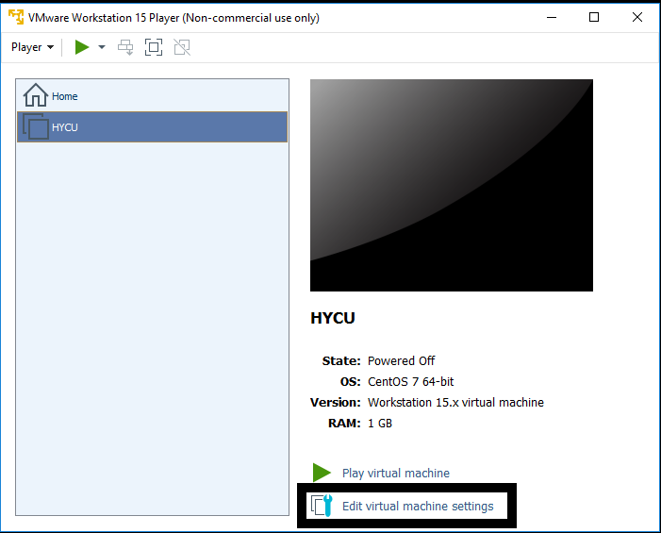
- Edit memory settings to 4 GB
- Edit Processors to 2 cores
- Remove the CD drive
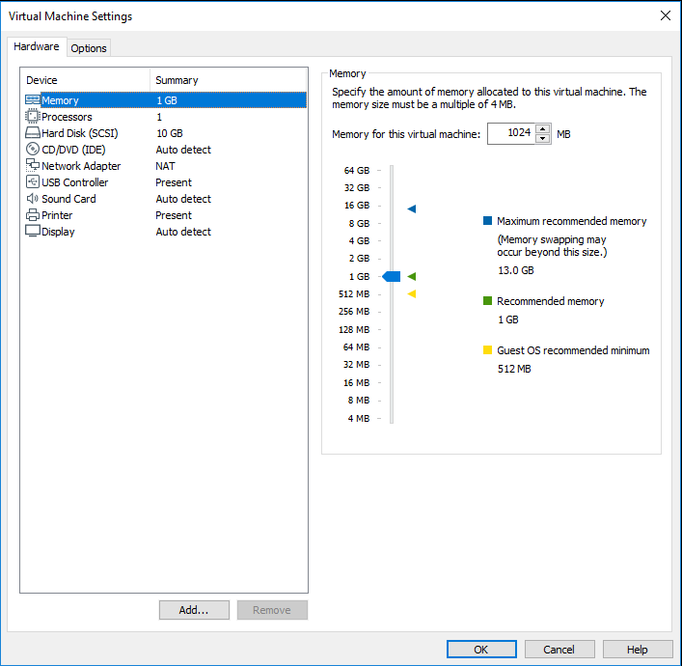

- Add another HDD, select SCSI hdd drive, "Use existing virtual disk" and browse for the HYCU data.vmdk disk image file. Click on finish and Keep existing format.
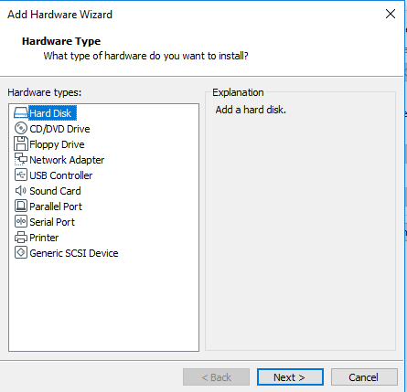
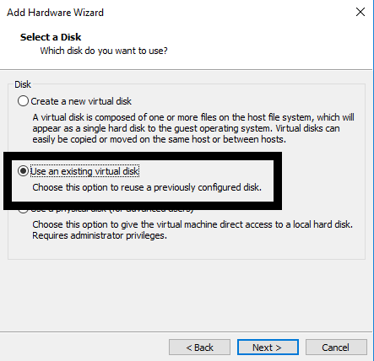
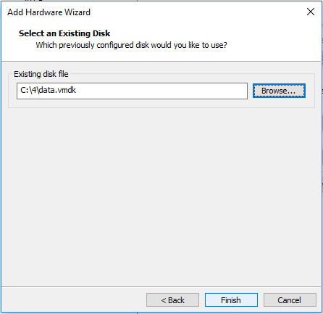
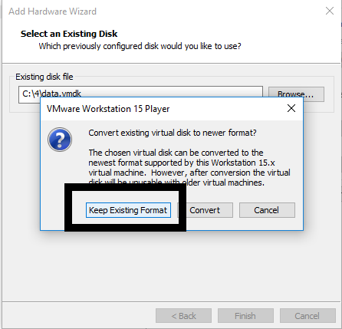

- On the network adapter select Nat
- Save the VM settings
- Run the VM
- When controller is up, login with your SSH credentials (by default this is hycu | hycu/4u). Use the command sudo nmtui to access network settings of the controller, you will be asked to enter the password one more time
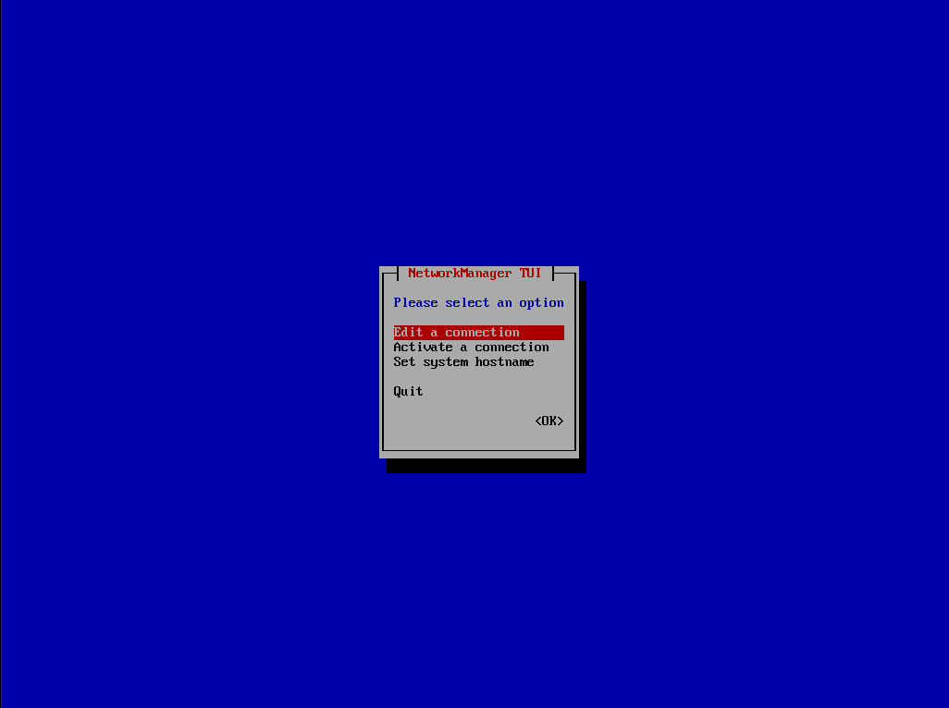
- Select Edit a connection
- Select Wired connection 1 and delete it
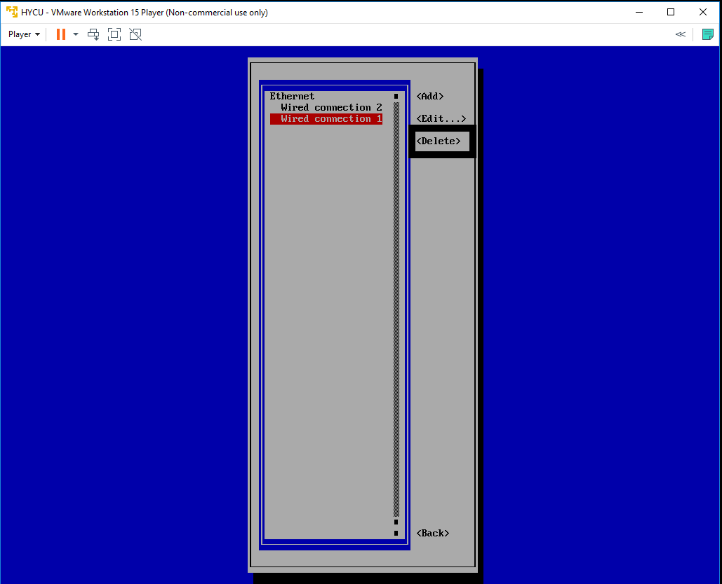
- Select Wired connection 2 and Edit it, change name to Wired connection 1
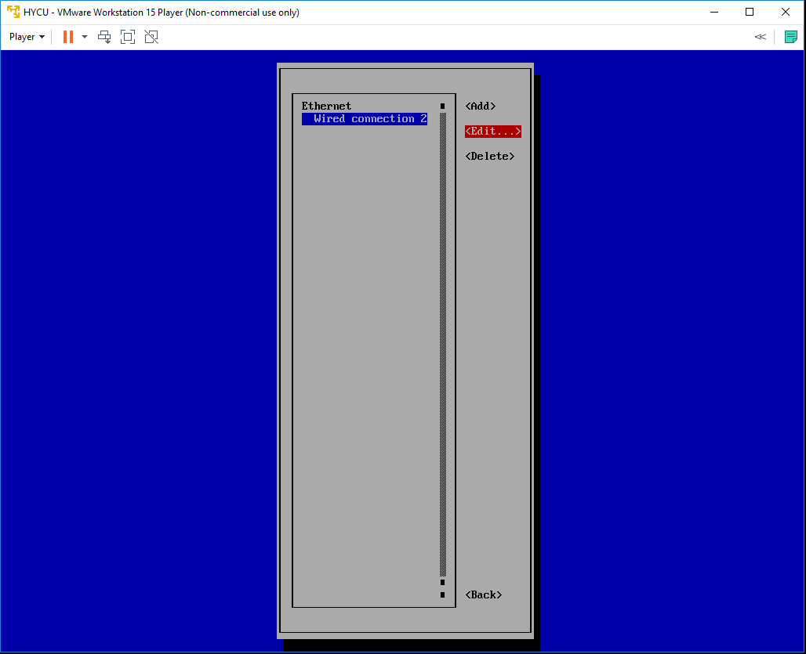
- Quit nmtui and reboot the HYCU controller VM by running sudo shutdown –r now
- SSH to the console with the same credentials and run ifconfig command to get controllers IP address
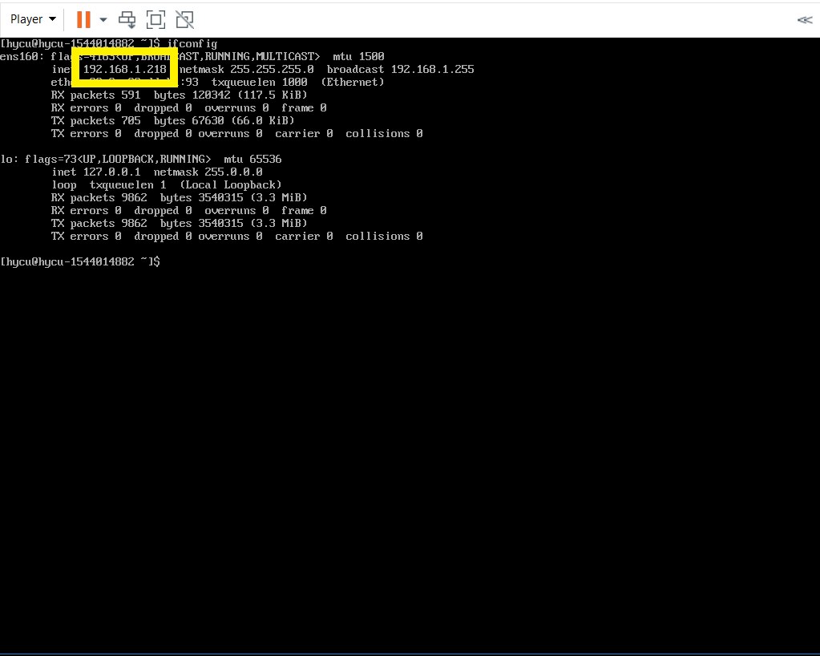
- Use that address to access HYCU GUI - https://IPaddress:8443

STEP 2 - Use HYCU to recover production virtual machines disk image files
  - video file
- Navigate to the HYCU Virtual Machines panel
- Protected VMs will be shown as PROTECTED_DELETED since source cluster is no longer available
- Select the desired VMs restore point and use “Restore VM or vDisks” option
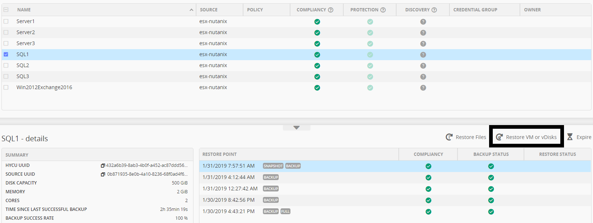
- New form will be shown. You can safely disregard the warning.
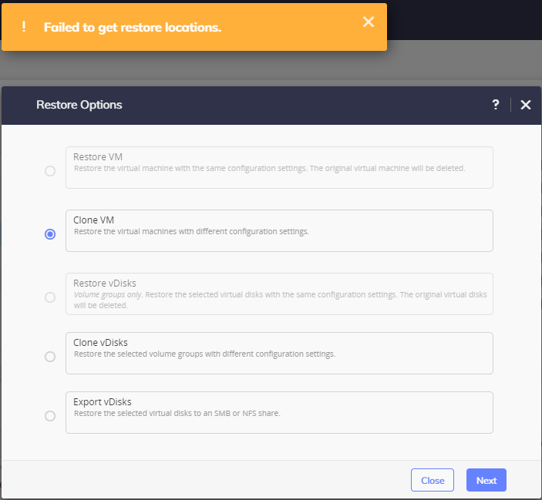
- Select “Export vDisks”
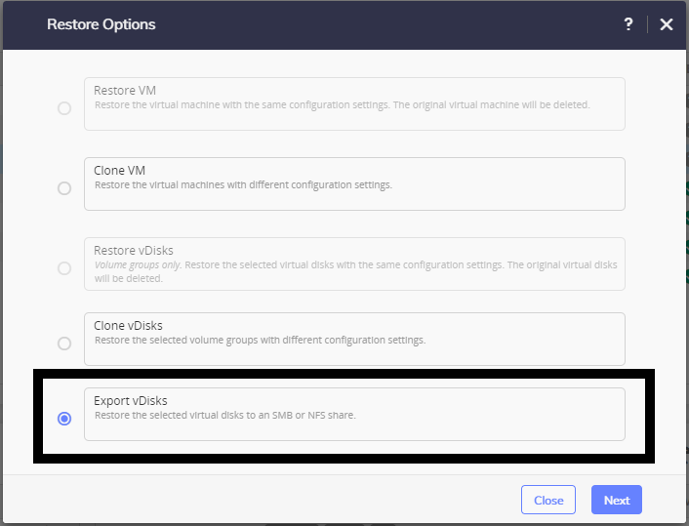

- Select vDisk(s) you want to export
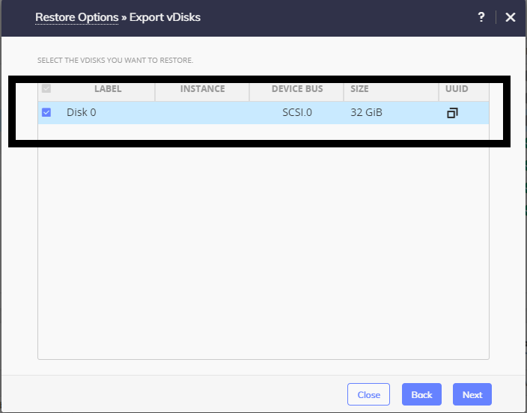
- Enter share Data
For SMB
- Domain, Username and Password are optional if exists
- Enter SMB server DNS name or IP address
- Enter Shared Folder name in format /<FolderName>
For NFS
- Enter NFS server DNS name or IP address
- Enter Shared Folder name in format /<FolderName>

- Restore Instance should be BACKUP
- Select Restore
- Once restore job is completed, you should have disk image files in specified folder. If you exported multiple disk you will have multiple raw (if exporting Nutanix ESX or AHV VM) or vmdk (if exporting non Nutanix VM) files in folder.
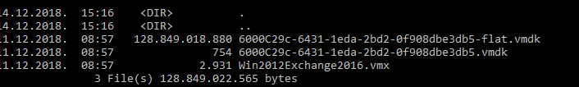

STEP 3 – Download and install Google Cloud SDK
  - video file
- Download Google Cloud SDK from address https://cloud.google.com/compute/docs/gcloud-compute/
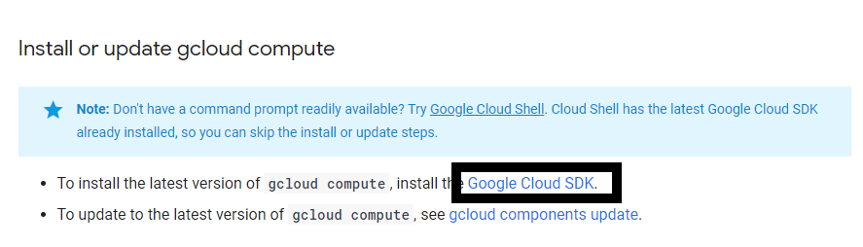
- Follow instructions from same page
- Login to Google Cloud dashboard and navigate to storage

STEP 4 – Create Bucket and upload VM files
  - video file
- Create Bucket
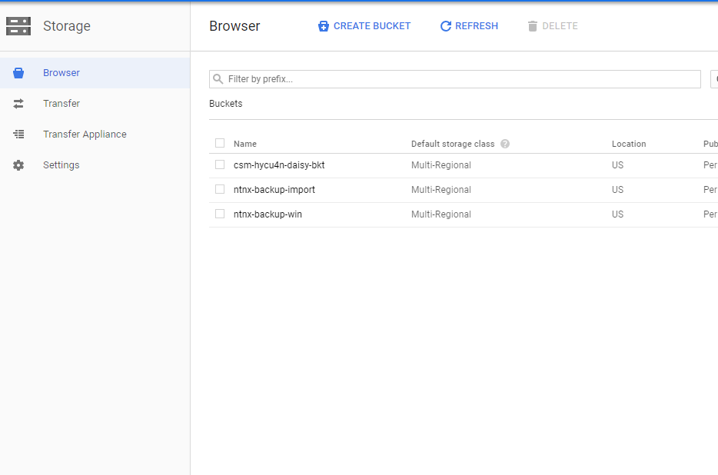
- Upload VM Disk files to bucket

STEP 5 – Import VM disk to custom images
  - video file
- Open Google Cloud SDK Shell
- Use https://cloud.google.com/compute/docs/images/importing-virtual-disks for additional info about importing
- Enter command gcloud compute images import hycu --source-file gs://<name of bucket>t/<name of virtual hdd file>.vmdk --os name of operating system
- Confirm with Y when you are asked to add permissions
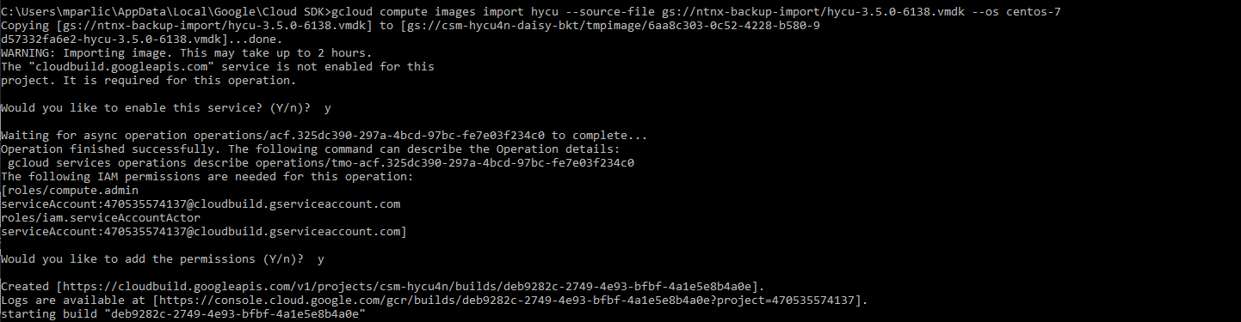
- When you see message like this import job is finished

STEP 6 – Deploy VM from custom image
  - video file
- Go back to your Google Cloud Web Console and select Compute Engine
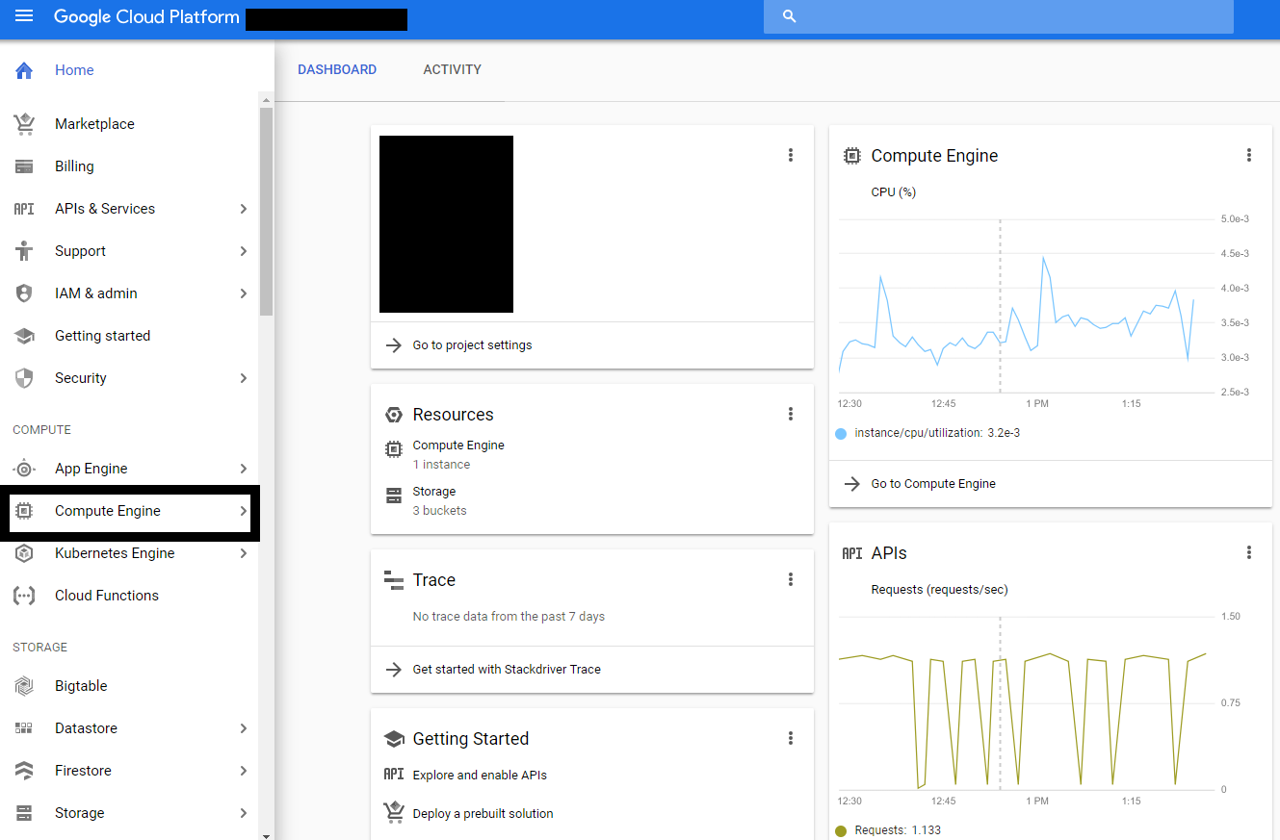
- Select Create Instance
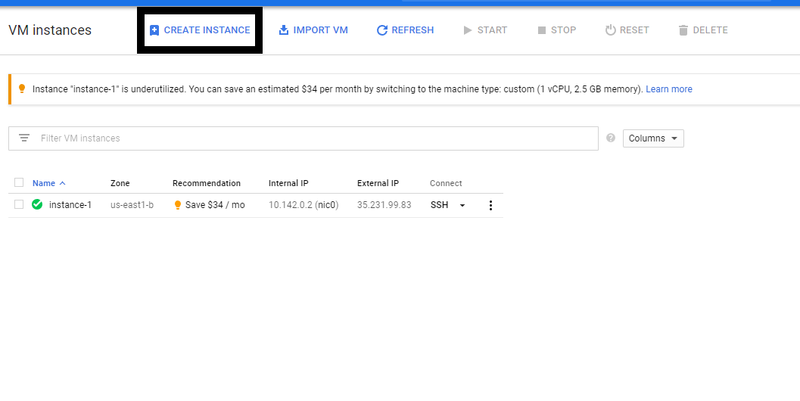
- Enter Instance name, set CPU and Memory config, and change boot disk
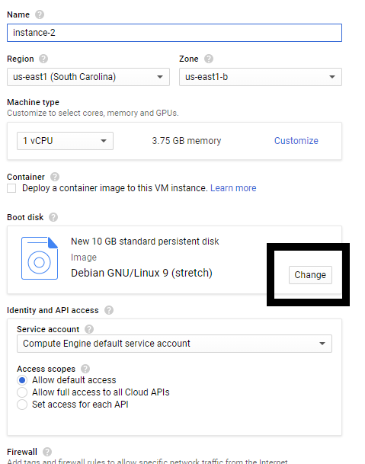
- Select Custom Images
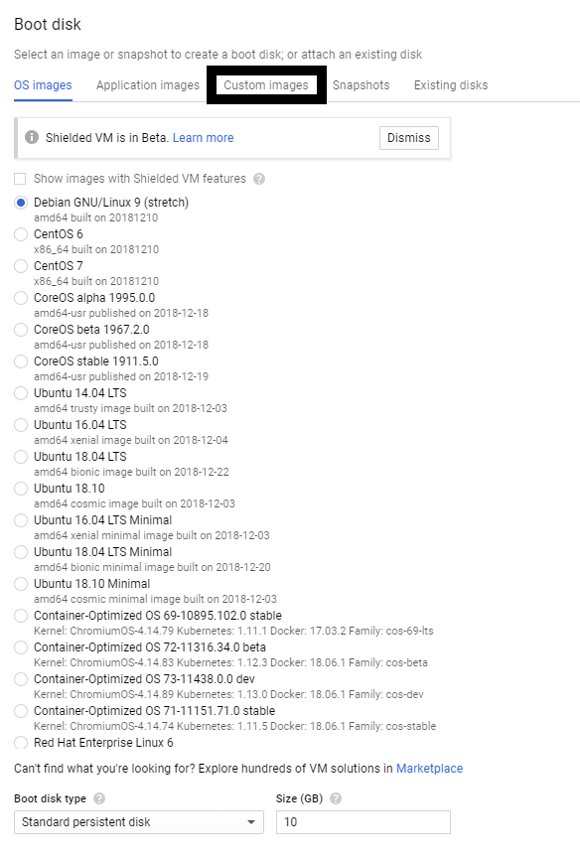
- From list select image that you imported
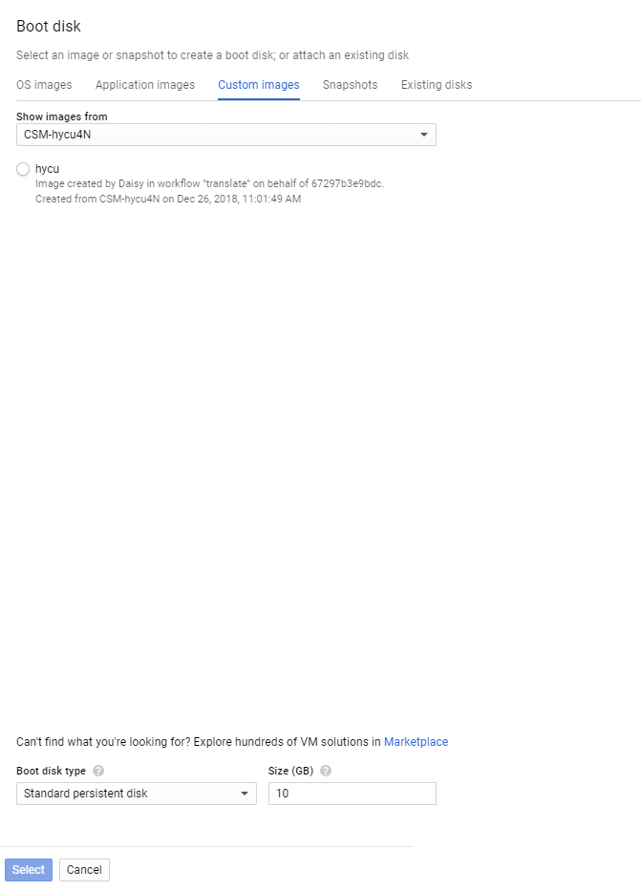
- Press Select
- Press Create
- When deploy of VM is done you can Power it on
- On VM instance page you will have internal IP and external IP for deployed VM

